

**A DEEP LEARNING METHOD TO DETECT HELMET AND NUMBER PLATE**

**Submitted by**

Joy Majumder

183-35-2582

Department of Software Engineering

Daffodil International University

**Supervised by**

Md. Shohel Arman

Assistant Professor

Department of Software Engineering

Daffodil International University

This Thesis report has been submitted in fulfillment of the requirements for the Degree of Bachelor of Science in Software Engineering

© All right Reserved by Daffodil International University

Approval

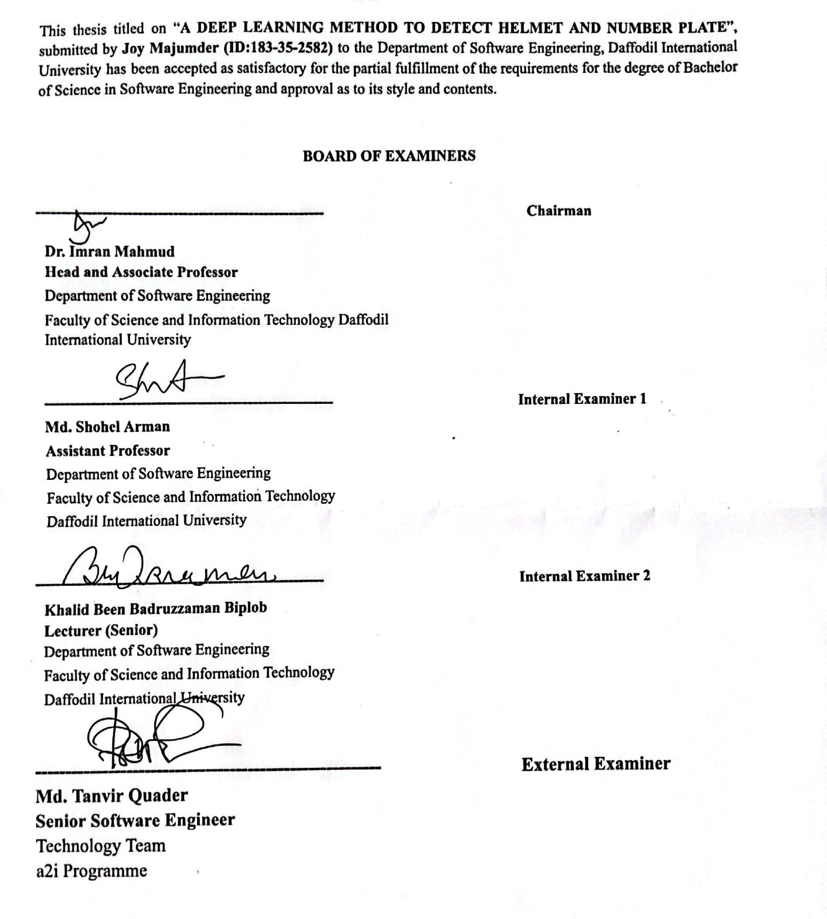

THESIS DECLARATION

I announce hereby that I am rendering this study document under Md. Shohel Arman, Lecturer, Department of Software Engineering, Daffodil International University. I therefore state that this work or any portion of it was not proposed here therefore for Bachelor's degree or any graduation.

Supervised by



………………………..

Md. Shohel Arman

Assistant Professor

Department of Software Engineering

Daffodil International University

Submitted by



…………………………..

Joy Majumder

183-35-2582

Department of Software Engineering

Daffodil International University

Acknowledgment

I would want to convey my sincere thanks to the All-Powerful God who provided my family and me with compassionate care throughout this trip till the completion of this endeavor.

I also want to express my gratitude to Md. Shohel Arman, an assistant professor in the department of software engineering at Daffodil International University, served as my honorary supervisor, for his appropriate direction, assistance, support, and collaboration. Without whom my thesis work would not be finished. This project was made feasible thanks to his never-ending tolerance, academic leadership, persistent encouragement, constant and vigorous supervision, constructive criticism, insightful counsel, reading several subpar versions, and fixing them at every level.

I'd want to thank every one of my Daffodil International University classmates who participated in this conversation while also attending class.

Finally, I want to express my appreciation to my parents and my brother, both of whom have always supported me. They consistently give my feedback and inspiration priority.

Abstract

Nowadays road accident is a very major issue for human death. Among road accidents, bike accidents are the biggest problem in our country. Every year, the number of deaths is increasing from the previous year. Bike accidents cause serious injuries to people because off-bikers do not use helmets. One of a motorcyclist's essential protective devices is a helmet. After there are laws and fines in our country about the use of helmets, bikers do not follow them. Solving this problem manually is a matter of a lot of money and time. So a system needs to be made which can automatically classify those who wear helmets and those who don't. There is already a system in place that wealthy nations have created that Bangladesh cannot afford. As a result, I made the decision to develop a system that will help in the authority's classification of helmet detection and number plate recognition. An image processing and convolutional neural network system are used in this case to identify the motorcyclists who are breaking the helmet rules. The system consists of motorcycle detection, categorization of wearing a helmet vs not wearing one, and motorcycle license plate identification. Using the YOLOv7 function, the motorcycles are detected. Once the motorcycle has been identified using a convolutional neural network, it is decided whether or not the rider is wearing a helmet. When a rider without a helmet is recognized, OpenCV Tesseract OCR is used to find the motorcycle's license plate. In the future, I will work on automatic case file systems that violate the helmet law and will increase the dataset to get higher accuracy.

Contents

Table of Contents

Approval i

THESIS DECLARATION ii

Acknowledgment iii

Abstract iv

Contents v

CHAPTER 1 1

INTRODUCTION 1

1.1 BACKGROUND 1

1.2 MOTIVATION OF THE RESEARCH 3

1.3 PROBLEM STATEMENT 4

1.5 RESEARCH OBJECTIVE 4

1.6 RESEARCH SCOPE 5

1.7 THESIS ORGANIZATION 6

CHAPTER 2 7

LITERATURE REVIEW 7

2.1 INTRODUCTION 7

2.2 PREVIOUS LITERATURE 7

2.3 CONCLUSION 16

CHAPTER 3 17

RESEARCH METHODOLOGY 17

3.1 RESEARCH METHODOLOGY 17

3.2 DATA COLLECTION 17

3.3 DATA PREPROCESSING 18

3.4 CONVOLUTIONAL NEURAL NETWORK (CNN) 20

3.5 YOLOv7 21

3.6 OpenCV OCR 24

3.7 Transfer Learning 26

3.8 Evaluation Methods 26

3.8.1 Accuracy 26

3.8.2 Precision 27

3.8.3 Recall 27

3.8.4 F1 Score 28

3.8.5 Mean Average Precision (mAP) 28

3.8.5.1 Confusion Matrix 29

3.8.5.2 Intersection over Union (IoU) 30

CHAPTER 4 31

RESULTS AND DISCUSSION 31

4.1 INTRODUCTION 31

4.2 RESULT DISCUSSION 31

4.2.1 YOLOv7 31

4.2.2 OpenCV OCR 38

CHAPTER 5 42

CONCLUSION AND LIMITATIONS 42

5.1 CONCLUSION 42

5.2 LIMITATIONS 42

6. REFERENCES 43

7. PLAGARISM REPORT 47

8. ACCOUNT CLEARENCE 49

9. LIBRARY CLEARENCE 50

**LIST OF FIGURES**

Figure 1: All type of the biker's sample picture 18

Figure 2: Type dataset sample 19

Figure 3 : Dataset Labeling 20

Figure 4: Convolutional neural network's basic architecture 21

Figure 5: YOLOv7 evaluate diagram 22

Figure 6: YOLO network Architecture diagram 23

Figure 7: The Flowchart for the training of YOLO 24

Figure 8: Program flow diagram 25

Figure 9: Confusion matrix diagram 29

Figure 10: Intersection over Union diagram 30

Figure 11: Mapping of YOLOv7 32

Figure 12: Confusion matrix of YOLOv7 33

Figure 13: Result of YOLOv7 34

Figure 14: F1, Recall, Precision of YOLOv7 36

Figure 15: Output of YOLOv7 37

Figure 16: Output of OpenCV OCR (1) 38

Figure 17: Output of OpenCV OCR (2) 39

Figure 18: Output of OpenCV number plate Recognition (1) 40

Figure 19: Output of OpenCV number plate Recognition (2) 41

**LIST OF TABLES**

Table 1: STANDARD CLASSIFICATION OF HELMET AND NUMBER PLATE 2

CHAPTER 1

INTRODUCTION

1.1 BACKGROUND

The use of autonomous systems for traffic control has become more crucial in recent months. One objective is to increase the efficiency of a traffic flow system, while others include lowering the cost of labor and reducing accident-causing factors.

A bike is the easiest way to go anywhere. But riding a bike is also a very risky job. Maximum bikers ride bikes without helmets. Many people die in bike accidents. One of the major causes of death in bike accidents is not wearing a helmet. The rule of all countries is to use a helmet as a safety measure while riding a bike. But many bikers do not use their safety equipment helmet while riding. Traffic police are always trying to solve these issues manually. But they are not able to solve it in this real situation. According to some surveys we see that in 2021 there was a total of 5731 road accidents in which 6284 people died, 927 were girls and 734 were children. Among these accidents, there were 2078 bikes which are 36.38% of the accidents of the whole year. Bike accidents have increased by 50.47% from the previous year and deaths have increased by 51.33% from the previous year. In many countries, 2-wheelers are responsible for most traffic accidents. ARI is the name of the Accident Research Institute (BUET) of the Bangladesh University of Engineering and Technology. 88% of motorcyclists involved in fatal collisions were not wearing helmets. By collision type, head-on collisions accounted for the highest number of fatalities (49%). In all these bike accidents, those who sustained head and neck injuries were not wearing helmets. This problem is much more in Bangladesh compared to other countries. Although many bikers in the town use helmets for fear of traffic fines, the bikers in the villages do not use helmets because there is not much traffic in the villages. Bangladesh traffic police need to check better to ensure that bikers are wearing helmets. Apart from the use of helmets by Bangladeshi bikers, another main problem is that many people ride these bikes on the road without registering the number after buying the bike. Which should never be done. Although there is a penalty for this, many people do not comply with it. Just like riding a bike without a helmet is a crime, riding a bike on the road without registering the bike number is also a big crime. We require techniques to identify motorbike photos and drivers from the image, then identify a region of the rider's head before classifying whether or not this individual is wearing a helmet in order to identify the bikers who don't wear helmets and to identify bikes that have been registered. There are numerous strategies and methods for tackling the detection issue. Researchers have employed a wide range of algorithms in these studies, with deep learning accounting for the majority of them. Since the work involves picture processing. For this reason, number plate identification and helmet detection are simple to detect and classify using deep learning.

Deep learning is a fairly common technique for identifying helmets and license plates from photos. Why is categorization methodology crucial? Because it is crucial to teach a model of who wears a helmet and who doesn't, as well as which bikes have license plates and which don't. These questions can provide all of the information. There had initially been many more sorts of native Bangladeshi bikers in a regular classification structure. These many biker's kinds are categorized under various class names. They are divided into the following 4 categories: Helmet, without helmet, Number plate, and without number plate. Using both a machine learning model and a deep learning technique, categorize bikers. Both bikers and other categories of people were categorized by some studies, while others only included bikers.

Table 1: STANDARD CLASSIFICATION OF HELMET AND NUMBER PLATE

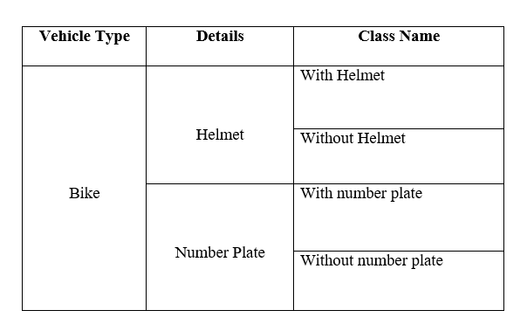

I use a categorized dataset in my job. I used a model to attempt to extract the number plate and helmet from the picture data. We had to locate the bikers in order to count them using the number plate and helmet that were identified.

1.2 MOTIVATION OF THE RESEARCH

Besides, riding a bike with a helmet is a big risk for all countries. Because of this, the person who rides the bike and the two people who sit behind the bike are at very high risk. Although there is a law about it in all countries, not everyone follows this law. On the contrary, if a bike accident occurs, the biker's life and the pillion may die. Maximum bikers do not use helmets while riding bikes. On the other hand, bike accidents are increasing day by day. We can see in many statistics that bike accidents are increasing because of not wearing helmets in other years. We also see that many bikers who don't have helmets also don't have number plates. Many of them have not registered the number of their bikes, and after that, they go out on the road with many of these bikes. This is a very serious crime in all countries. They should be solved very soon. Otherwise, accidents will not decrease and people dying will not decrease. On the other hand, we see that many foreign countries are already doing a lot of work on them. But in our country, there is not much work on it, and there is not much research.

Other countries do their work with their own data. There is no such data in our country. That's why we want to work with our own data. Helmet detection and number plate detection are a matter of time and a lot of money. They are developing it in many parts of other countries. They are detecting this problem very early and in less time, where nothing has happened in our country. By getting inspiration from them, we need to consider gathering data on helmets and license plates from bikers in rural and urban areas of Bangladesh. Although bikers in Dhaka keep helmets and number plates for fear of traffic, maximum bikers ride bikes without helmets outside Dhaka. . Unhelmet drivers are not usually caught by traffic enforcement.

Therefore, in order to make it easier for the traffic to identify bikers' helmets and license plates, a method was developed to do just that. Therefore, the goal of the study is to create a low-cost system for our nation that will produce the best outcomes based on data from the nation's motorcyclists.

1.3 PROBLEM STATEMENT

Wearing a helmet reduces the chance of severe head injuries, comas, and death for riders. The helmet protects many parts of our body. Notable among them are Traumatic brain injury, concussion, facial fractures, broken jaws, dental problems and tooth loss, damage to the ears, eyes, and face, as well as scars and disfigurement. A lot of work has already been done with helmet and number plate detection. Different sorts of algorithms, including Deep Convolutional Neural Networks, CNN, R-CNN, embedded systems, and many more, are used by many of the researcher's authors. Some strategies also include cutting-edge solutions. There are some methods for bike number plate and helmet detection. They used SVM, Random Forest, decision trees, and many more classification techniques to determine the types of automobiles. With several systems, they gathered the data. Some employed bespoke datasets, while others made use of readily accessible global data. In other countries, they work with their own data on their bikers. But the climate and situation of Bangladesh are completely different from other countries. The study, therefore, has relevance for their own nation. On the dataset obtained from the bikers in Bangladesh, we wish to use deep learning models. The local bikers from Bangladesh belong to diverse social classes. They are wearing a helmet, not wearing a helmet, and not wearing a number plate.

1.5 RESEARCH OBJECTIVE

My paper's major goal is to identify helmets and license plates at a minimal cost from a different locations. Additionally, we aimed for a better outcome to increase the applicability of our concept. Our thesis is:

* Establishing an automated system.
* For constructing a cheap system that a developing nation like Bangladesh might afford.
* Using people wearing and not wearing helmets, number plate recognition
* install on any traffic management system

1.6 RESEARCH SCOPE

**The following are the primary research areas:**

* To create a method based on the native bikers of Bangladesh that can identify motorcyclists wearing helmets and the condition of their license plates from pictures in order to collect data on helmet users and non-users.
* Will benefit the Bangladeshi government by having a system that is low-cost, will quickly identify who uses a helmet when riding a bike and who doesn't, and will also identify whether a number plate is present on the bike in question. Therefore, it will aid the authorities in reducing injuries from bike accidents and in identifying the primary offender.
* We can easily find out how many bikes are running on the road and how many bikes are polluting the air.
* We will try to make an alarm system so that the message goes to the rider without a helmet very easily.
* The traffic police will be greatly benefited from this system. They will be able to detect and file cases very easily and it will reduce their suffering a lot.
* As a result of this system, recognition of number plates can be done very easily and the data of the bike owner can be checked and the case file in his name will be convenient. Which will be a boon for traffic management

1.7 THESIS ORGANIZATION

The background of the study, the rationale for the research, the issue description, the research questions, and the research purpose are all covered in the first chapter in particular detail about the helmet and number plate identification system and its application. The following are the additional components of our research:

In the second chapter, I'll talk about the literature review, which allows us to see previous research on helmet-related concerns, the methodologies utilized, any gaps, and a comparison of my work and other researchers' work based on our mutual understanding of their findings.

Our research methodology will be covered in the third chapter. Data collection, data pre-processing, and work analysis will all be covered in the methodology section of my paper.

Also covered is how the methods work. Which method is used in which task? Which method comes from which model?

In chapter four, the methodology's findings will be discussed, and also discussed all types of result accuracy many scores. For this discussion, we can easily understand this paper and understand all accuracy and helmet detection, and recognition of number plates.

The final chapter serves as the conclusion. Here I will provide the conclusion, which will include a complete summary of my work. Here, I've talked about the work I'll perform going forward to improve the work.

CHAPTER 2

LITERATURE REVIEW

2.1 INTRODUCTION

In a literature review, a researcher examines prior work, research, conference papers, books, articles, etc. With this information, one can learn what work has already been done on the issue, summarize it, and identify gaps in the work. After analysis, they might focus on limits and find ways to get around them to get better results.

2.2 PREVIOUS LITERATURE

The idea of ​​helmet detection is mainly coming since many people died in bike accidents due to not wearing helmets. And this was only increasing day by day from other previous years. The roads of Bangladesh are not very suitable for driving. Moreover, 2-wheelers are riskier. Bike safety equipment helmets are mainly used to reduce these risks. But still, riders do not want to use this helmet. Many researchers started working on it. I got very good results from this. Again, many of them could not go to their main goal properly. Many researchers have done detection classification using many models. I want to do my work to better detect and classify which bikers are wearing helmets and which bikers aren't wearing helmets and see how it can be done at a low cost. Many related paper reviews are done for this work.

S. Sanjana and et al. [1] worked on detecting and classifying motorcycle riders who do not wear helmets. They used VGG16, VGG19, Inception v3, MobileNet, RCNN, Naive Bayes, HOG, SVM, and YOLO v3. They used both machine learning and Deep learning for classification and detection. They use the data of images captured on a digital camera. The limitation of this paper is can be added number plate recognition.

R. Badaghia and et al. [2] evaluated the detection of bikers not wearing a helmet, classification method appropriately discriminates between the two classes of helmet and non-helmet. This article suggests a technique for processing images based on the Descriptors for spotting bikers without helmets including Local Binary Pattern (LBP), Local Variance (LV), and Histogram of Oriented Gradient (HOG). This work utilized secondary data from a database that was provided by another paper. The suggested technique enhanced bicyclists' helmet detection both in terms of computational complexity and accuracy. They used a Support Vector Machine classifier for helmet detection. The accuracy of the proposed helmet detection method is 98.03%.

B.SOUNDARYA and et al. [3] worked Using image processing and convolutional neural networks, a system created to identify motorcycle riders who are disobeying helmet laws. The system includes bike detection, classification of helmet use versus absence, and bike license plate identification. For detection, they used the HOG method and for number plate recognition they used tesseract OCR. They used collected data from various CCTV cameras. To address the issue of ineffective traffic management, the project was primarily constructed.

M.Srilakshmi and et al. [4] detect using Deep Neural Networks, object identification and classification were done in real-time video. They evaluated the determining whether a rider of a two-wheeler is wearing a helmet or not and if not, obtaining the license plate of that two-wheeler. They used the YOLO model for detection and used OCR for number plate recognition. They used real-time video footage. The project successfully completes all of its goals.

Fahad A Khan and et al. [5] worked for classified motorcycles rider with or without a helmet from images and detect license plates of motorcyclists detected from various observation sites. They used YOLOv3, darknet deep learning framework, and CNN algorithm for detection and classification. Dataset was collected from OpenImages Dataset, our manually captured images, and the Unsplash website. The limitation was Expanding the dataset could improve the precision and accuracy of the objects.

Tanupriya Choudhury and et al. [6] wanted to suggest study is concluded by creating a system that can recognize items using transfer learning from a unique dataset. The main method for implementing the system is deep learning utilizing the SSD MobileNet V2. They use data from cameras on road to capture traffic and some data collect from YouTube. For future research, the number plate processing will be expanded in order to construct a database of defaulters compiled by the system.

Narong Boonsirisumpun and et al. [7] evaluated the Single Shot MultiBox Detector (SSD) in a helmet detection problem in deep learning. They identify the motorcycle and rider's boundary boxes before classifying whether or not the rider is wearing a helmet. They used CNN, VGG, Google Net, and Mobile Nets methods for detection and classification. For this paper datasets were collected from the video surveillance system of Loei Rajabhat University in Loei province, Thailand. Future research will broaden our experiment by using more CNN models or other Deep Learning approaches to compare our results with MobileNets and Inception V3's image categorization performance.

Rohith C A and et al. [8] the first thing they wanted to do was categorize any photos of people on two wheels. They also wanted to aim to create a machine that can automatically identify, determining if a biker is wearing a helmet and fining those who are not as part of legal enforcement. The Caffe model is utilized for the detection and extraction and this accuracy they have 76%. And InceptionV3 was used for classification and this accuracy was found 81%. For the dataset, they used Traffic cameras to shoot the videos from the desired locations. The limitation of this work was to use of different models to analyze the accuracy and choose the best models.

Abhijeet S. Talaulikar and et al. [9] approach for automatically identifying motorcyclists who are not wearing helmets. They employed various machine learning algorithms on the chosen attributes to identify the helmet from the motorcycle item and carried out a feasibility study. For detecting helmets they used AMG, HOG, SVM, Naïve Bayes, decision tree, random forest, and KNN. Data was collected from a video feed from the surveillance camera deployed on roads.

Dikshant Manocha and et al. [10] have used machine learning to identify two-wheeler riders without a helmet and give them a user interface for challan payment. They used an OpenCV method for checking riders and pillion riders are warning a helmet or not. Then they used OCR for number plate recognition. If any rider or pillion rider doesn't have a helmet after that OCR has processed. Afterward, a challan will be generated using the car registration number generated against the appropriate bike, and all of the challan's information will be delivered to the appropriate individual via email and text message. For dataset used the information from the CCTV cameras for collecting real-time footage of traffic. This step may lead to error in inclement weather when it is difficult to read the license plate.

Lokesh Allamki and et al.[11] detected whether the rider used a helmet or not using the deep learning model. A license plate is retrieved when a rider without a helmet is detected, and an optical character recognition device is used to identify the license plate number. They used the YOLOv3 model for helmet detection. They also used OCR for number plate recognition. They use a Webcam or a CCTV as input. A machine learning-based technique is used to construct a custom object detection model that can identify motorcycle riders. If deployed by any traffic, they claim Management departments' jobs would be made easier as a result. and more productive.

Kavyashree Devadiga and et al [12] implemented successfully identify every model of helmet, using only machine learning. They used the COCO model for object classification. They also used the YOLO model for detection and the OCR model used for number plate recognition. For the database, they used video surveillance of the street. The suggested method automatically determines if the bike rider is wearing a helmet without human assistance. The vehicle's license plate is read and recorded.

Dharma Raj KC and et al [13] worked for finding motorcyclists who are violating helmet laws using image processing and deep convolutional neural networks. They discovered several things, including motorbike detection, a categorization of helmet wearers against non-wearers, and motorcycle license plate identification. They used CNN, SGD, and AdaGrad methods. They used a dataset for video clip locations in Bangkok and Phuket, Thailand. They installed the device on at five junctions in Phuket as well as one intersection (Din Daeng) in Bangkok.

Ahatsham Hayat and et al [14] worked for an automated safety helmet detection system for a construction site is presented in this study and is based on the You Only Look Once (YOLO) principle. They used YOLOv3, YOLOv4, and YOLOv5x to detect safety helmets with object detection task. In this work, 5000 hard hat photos from a benchmark dataset were employed. These images were then separated into training, testing, and validation subsets in a ratio of 60:20:20 (%). One of them, YOLOv5x, demonstrated its effectiveness in safety helmet identification by achieving the best mAP (92.44%) in recognizing smaller items and objects in low-light photos. To provide improved worker safety, additional safety equipment for detection, such as vests, gloves, and glasses, may be added in the future.

Lixia Deng and et al [15] designed a new YOLOv3 network and suggests a simple object detection method. First, two great networks, the Cross Stage Partial Network (CSPNet) and GhostNet, are combined to create the CSP-Ghost-Resnet, a more effective residual network. Second, this study creates a new backbone network called the ML-Darknet to implement the gradient diversion of the backbone network by integrating CSPNet and Darknet53. They also design the PAN-CSP-Network is a compact multiscale feature extraction network. The paper's safety helmet datasets include 7,581 pictures from various application scenarios. The study preprocesses the current datasets to enhance the network's training performance. Studies have revealed that ML-FLOPs, YOLOv3's parameter sizes, and speed are only 29.7%, 29.4%, and 56.4% of those of YOLOv3, respectively. With less computational expense than YOLOv5m, ML-YOLOv3 outperforms YOLOv5 in terms of detection performance.

Munkh-Erdene Otgonbold and et al [16] provides the SHEL5K dataset, an improved version of the SHD dataset for safety helmets. There are six fully labeled classes in the proposed dataset (helmet, head, head with helmet, person with helmet, person without helmet, and face). YOLOv3, YOLOv3, YOLOv3-tiny, and YOLOv3-SPP, YOLOv4, YOLOv4pacsp-x-mish, YOLOv5-P5, the Faster Region-based Convolutional Neural Network (Faster-RCNN) using the Inception V2 architecture, and YOLOR were all used to evaluate the suggested dataset.The suggested dataset's experimental results from the various models were compared, and the mean Average Precision improved (mAP). The SHEL5K dataset has an edge over previous safety helmet datasets since it had fewer photos with better labeling and more classes, which improves the accuracy of helmet recognition.

Bin Zhang and et al [17] worked for an enhanced YOLOv4-tiny safety helmet-wearing detection method, SCM-YOLO, is presented to address the issues with object recognition in complex scenarios based on the YOLOv4-tiny algorithm, such as insufficient feature extraction, low accuracy, and low recall rate. In order to strengthen the YOLOv4-tiny model's capacity to adapt to various scale characteristics and to raise the effectiveness of its feature extraction capabilities, the Spatial Pyramid Pooling (SPP) structure is first implemented after the backbone network. In order to increase the detection speed while maintaining accuracy for tiny objects, Convolutional Block Attention Module (CBAM), Mish activation function, K-Means++ clustering technique, label smoothing, and Mosaic data improvement are introduced. After a significant number of tests, the proposed SCM-YOLO algorithm obtains a mAP of 93.19%, which is 4.76% higher than the YOLOv4-tiny method. Dataset, which includes 2580 photos, was created using information from Liuzhou Wuling Automobile Co., Ltd. (Guangxi Automobile Group).

Fan Wu and et al [18] In this study, the backbone of the Densenet network is modified using YOLO V3. It solves the issue of faulty detection and overlapping bounding boxes in the initial network. We connect the YOLO V3 network's original output techniques for prediction and extract features through the new network structure. The experimental findings demonstrate that the optimized target detection network enhances the capability of identifying safety helmets and can offer superior reference results for security monitoring apparatus. Pictures from the Internet and a small number of our own photos make up the data set used in this experiment. There are three sets of images: a train set, a validation set, and a test set. They used YOLOV3 and YOLO-Dense backbone for detection and they compare those two accuracy and YOLO-Dense backbone increased 2.44% map accuracy.

Kang Li and et al [19] Worked for created an innovative and useful technology to detect whether perambulatory workers are wearing safety helmets or not. They used ViBe background model for superb motion object detection. They also used C4 pedestrians classification algorithm for worker location quickly. This safety helmet wearing detection system's usefulness and efficiency have been demonstrated by extensive trial findings. They worked on developing stronger detecting techniques that will be used in the future. Our method's AUC is 94.13%, compared to the HOG feature extraction and SVM classifier method's AUC of 89.20%. It gains about 5%.

Shilei Tan and et al [20] approached for deep learning based method for detecting helmet and non helmet. The majority of the safety helmet wearing dataset's data was gathered by web crawlers. 6,000 photos in total have been gathered to make the training and test datasets. Helmet and Head are two categories in the datasets. They used YOLO v5 model for ability detecting scale to enable it to obtain a smaller target. They also used DIoU-NMS instead of NMS for more precisely suppresses the anticipated bounding box due to the central distance between the two boxes. The experimental outcomes demonstrate that the proposed algorithm greatly increases accuracy in comparison to the YOLOv5 network model, and detection speed is 98 frames per second, which may satisfy the requirements of real-time detection.

Madhuchhanda Dasgupta and et al [21] implemented a system for identifying motorcycle riders who do not wear helmets, whether they are one or many. For dataset they used traffic videos captured by surveillance camera. The state-of-the-art method for object recognition, YOLO model, is updated in the suggested method to create YOLOv3, which is used to detect motorbike riders in the first stage. In the second stage, an architecture based on convolutional neural networks (CNNs) has been suggested for detecting motorbike riders wearing helmets. Comparing the results to other CNN-based methods, they are encouraging.

Rao Cheng and et al [22] worked for safety helmet detection using SAS-YOLOv3-tiny algorithm. They also worked for balance detection accuracy and model complexity. For their dataset, a collection of safety helmet datasets was created, consisting of 7656 images that were gathered from web searches, camera and web crawler photography, and formatted in VOC format. labelImg software used for labeling collected images. They compared his model accuracy in other model which is YOLOv4. In comparison to the most recent YOLOv4-tiny, SAS-YOLOv3-tiny increases R from 80.0% to 80.9% and mAP from 78.9% to 80.3%, but somewhat reduces P and F1. The results of the experiment and the contrast curves show that the revised methods can increase the effectiveness of detection.

Wei Jia and et al [23] worked for deep learning-based automated helmet identification for motorcyclists is provided. They used two method for detecting helmet. In the first stage, motorbikes (including motorcycle riders) are found in video surveillance using the upgraded YOLOv5 detector. The upgraded YOLOv5 detector is used again in the second stage to determine if the motorcyclists are wearing helmets by using the bikes identified in the first step as input. Triplet attention is fused with the YOLOv5 detector, and soft-NMS is used in place of NMS. They utilized data collected from several Chinese city traffic monitoring systems. In the end, they developed a system that exceeds other cutting-edge detection techniques with a mAP of 97.7%, F1-score of 92.7%, and frames per second (FPS) of 63.

Zhang Jin and et al [24] offered a more effective way to identify YOLOv5 helmet use. First, they performed dimensional clustering on the dataset of the scene of the self-made building process using the -means++ method; then, they integrated the backbone network and DWCA attention mechanism to collect more specific information. The majority of the photos used for the dataset in this piece came from Internet crawling, construction site self-collection, and security video framing of the site. In the end, their model's high detection accuracy can match the detection accuracy of helmets in the present complicated operational environment.

Abhishek Kashyap and et al [25] worked in order to read the image of the car number plate, the OCR (Optical Character Recognition) system was used. First, they take a picture of the license plate, then they analyze it and read each and every character to ensure a perfect match. The most important stage is OCR, where letters on the picture of a license plate are converted into sentences that can subsequently be decrypted. In this study, ANPR and its effective applications are demonstrated using a comprehensive algorithm and network flow. The ANPR system's idea is based on matching templates, and its accuracy (outcome) was determined to be between 75 and 85% for Indian number plates.

R Naren Babu and et al [26] approached a training-based route for recognizing license plates. Their major goal in their work is to build a reliable number plate recognition model that operates in a variety of lighting and viewing angles. By utilizing YOLO V3 to train on our manually gathered automobile number plate dataset, they developed their recognition model. Over 640 photos with various lighting and color schemes have been used to test the algorithm.

Bhavin V. Kakani and et al [27] devoted to a better method of OCR-based license plate identification employing a trained neural network dataset of object characteristics. In order to increase accuracy, a blended algorithm for license plate recognition is suggested and put up against current techniques. Three main modules, namely License Plate Localization, Plate Character Segmentation, and Plate Character Recognition, may be used to classify the whole system. 300 motor vehicle LP photos from throughout the nation and the world are used to simulate the system, and the results produced support the primary need.

Deng Benyang and et al [28] developed a technique based on the upgraded YOLO v4 for identifying helmet use. They also used YOLO v3, Faster R-CNN for detecting helmet. In order to develop a dataset for helmet recognition, they combined video feeds from the construction site and images gathered by the auxiliary web crawler. The experimental results demonstrate that, in the helmet wearing detection task, the model mAP value reached 92.89%, the detection speed reached 15 f/s, and its detection accuracy and detection speed were improved in comparison with YOLO v4, which complies with the real-time needs of the helmet detection task.

Haikuan Wang and et al [29] worked for To enhance target recognition on the construction site, a novel SHW detection model called CSYOLOv3 is given. It is based on an improved version of YOLOv3. The cross stage partial network (CSPNet), which lowers the cost of computation and increases training speed, is first applied to the backbone network of darknet53 to improve it. Second, the YOLOv3 model uses the spatial pyramid pooling (SPP) structure to improve the multi-scale prediction network by fusing top-down and bottom-up feature augmentation methodologies. The construction site cameras are used to build a safety helmet wearing detection dataset with 10,000 photos, and the model training requires manual annotation. Experimental results and contrastive curves show that speed is increased by 6 fps and mAP is significantly reduced by 28% when compared to YOLOv3.

Prajwal M. J. and et al [30] a non-helmet rider detection system is created in an effort to automate the process of identifying this traffic infraction and obtaining the vehicle's license plate number. Three stages of Object Detection using Deep Learning constitute the primary idea.

At the first level using YOLOv2, the items recognized are a person, a motorbike or scooter, a helmet, and a license plate. At the second level using YOLOv3, the things detected are a license plate. Then, using OCR (Optical Character Recognition), the license plate registration number is retrieved. All of these methods, particularly the one that extracts license plate numbers, are subject to predetermined restrictions and circumstances. The speed of execution is essential for this operation since video is used as its input. They developed a comprehensive system for both helmet detection and license plate number extraction using the aforementioned approaches. A dataset comprising 832 pictures of bikes and mopeds with their license plates was assembled for training purposes.

2.3 CONCLUSION

Algorithms come in a variety of forms. They used a variety of techniques, including feature extraction, augmentation, annotation, and more, to achieve a decent outcome. Leave real-time performance and increased accuracy behind. In our efforts, we also tried to make it simple to identify riders who don't wear helmets while riding and to work on real-time traffic data.

CHAPTER 3

RESEARCH METHODOLOGY

3.1 RESEARCH METHODOLOGY

On a dataset obtained from our own dataset, we have utilized YOLOv7 and OpenCV OCR.

3.2 DATA COLLECTION

Every research project begins with the collection of data. When we say that data is being collected, we mean that it is being done in a methodical way. Data collection is a very important part of any research. By data collection we mean it's a systematic process of gathering observations and measurements. There are many reasons for these people to collect data, some of them are for business and some governments collect them for their academic work. My data is mainly bike related. Data. Although there is a lot of data about bikes or riders in other countries, there is no such source in Bangladesh. As a result, many cannot work with the riders even if they want to. So I was thinking of collecting some data so that I can work with that data and make something good out of it for the country. For this, I traveled all over Bangladesh and started making videos of rider and rider pillion and a half helmet reading and video of bike number plate. All Images and videos were collected by smartphone. The data is collected from many positions. Some data was collected during rain. Some data was collected at night. And maximum data has been collected during the daytime. While collecting this data, I did not get the data of all classes equally. The maximum data of the total data collection is the helmet class and the 2nd maximum is the number plate data. Except for helmets and number plates, data is very less available. Which is good to think in one direction that is people of our country maximum wear these helmets and they have number plates too.

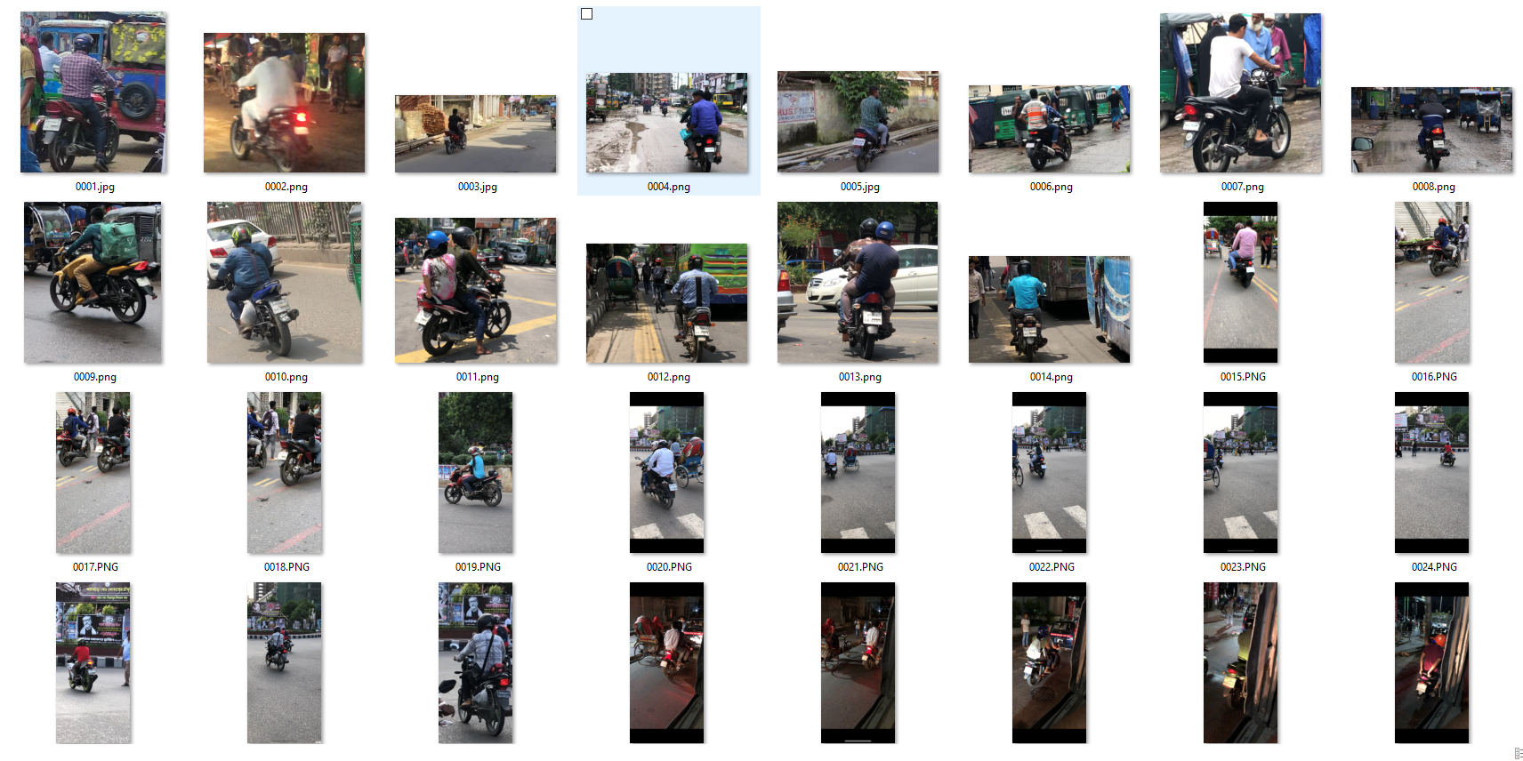

Figure 1: All type of the biker's sample picture

3.3 DATA PREPROCESSING

Data preprocessing is an important stage in the process of putting the data into a usable format. Data mining includes the stage of data preprocessing. I have collected data from many different areas in Bangladesh. The dataset has 1000 images of bikers and bike number plates. Additional annotation was made to this data. The labels on the objects in the matching image are precisely stated in these files. The annotated files were exported in two separate formats: YOLO and XML. For annotation, we are selecting 4 classes for annotation. Those classes are Helmet, Without Helmet, Number Plate, and Without Number Plate. After collecting the data and preprocessing we divided those images into 2 folders. I separated the data into sets for training and validation. the training dataset contains 80% of the data and 20% of the data in the validation set. After dividing the dataset train folder have 800 images and the validation folder have 200 images.

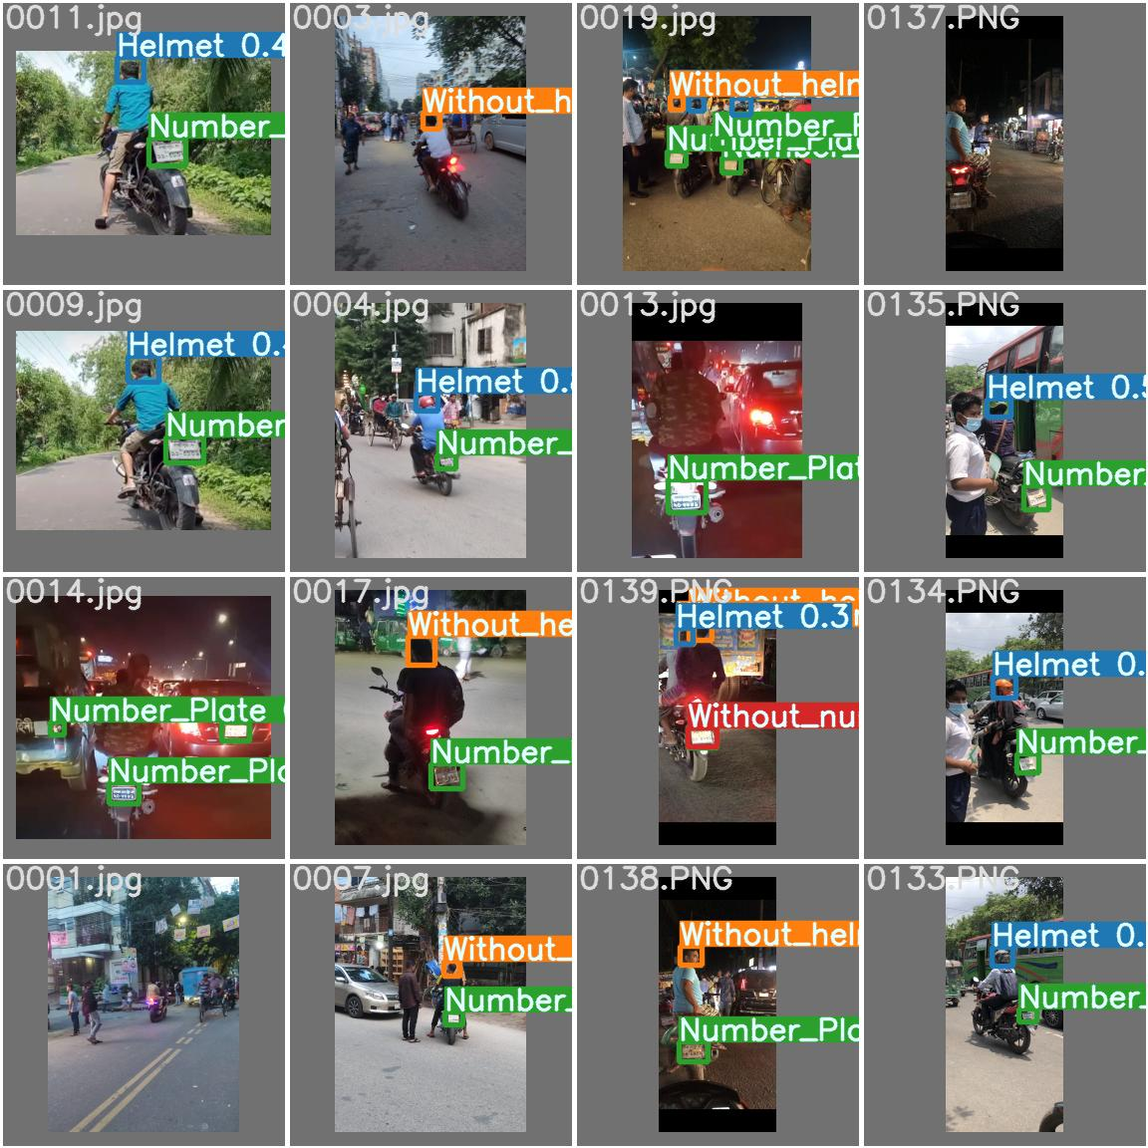

Figure 2: Type dataset sample

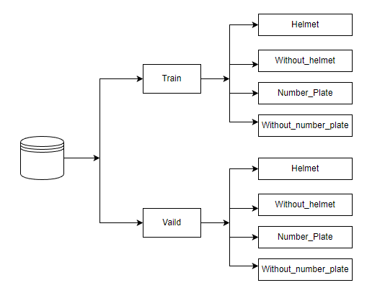

Figure 3 : Dataset Labeling

3.4 CONVOLUTIONAL NEURAL NETWORK (CNN)

What we must know is convolutional neural networks are A class of deep learning. Convolutional neural networks (CNN or DCNN) are the most common it is used to identify images and videos. It was first used in 1980.

So, here the CNN’s (Convolutional neural network) basic idea is explained (figure 4)

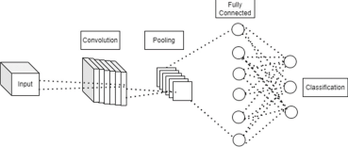

Figure 4: Convolutional neural network's basic architecture

Using any deep learning model requires a lot of data. CNN's, which use a three-dimensional neural pattern inspired by the visual cortex of animals, have evolved from traditional artificial neural networks. Convolutional neural networks are frequently used for natural language processing, although their principal applications include object identification, picture classification, and recommendation systems. Convolutional neural networks use pictures as input and train a classifier with them. Instead of matrix multiplication, the network uses a unique mathematical procedure called "convolution." A convolutional network's design generally comprises four layers: convolution, pooling, activation, and fully linked.

3.5 YOLOv7

First of all, we have to know what is YOLO? The phrase "You Only Look Once" is referred to as YOLO. There have many versions of the YOLO model. The YOLO model was initial release in 2016. An algorithm known as YOLO can find and identify a variety of things in an image (in real-time). The class probabilities of the identified photos are provided as a result of the object detection process in YOLO. The new version of YOLO can work 10x faster than the previous models. The last version of YOLO is version 7. It is much faster than all other models and its batch fps is much higher and it's batch average time is less than before. In July 2022, Chien-Yao Wang, Alexey Bochkovskiy, and Hong-Yuan Mark Liao published the official YOLOv7 article, which was titled "YOLOv7: Trainable bag-of-freebies sets new state-of-the-art for real-time object detectors." We can easily find YOLOv7 in the official YOLOv7 GitHub repository.

Here we see YOLOv7 evaluates in the upper left-faster and more accurate than it is per the network diagram, YOLOv7 network architecture diagram and Flowchart for the training of YOLO:

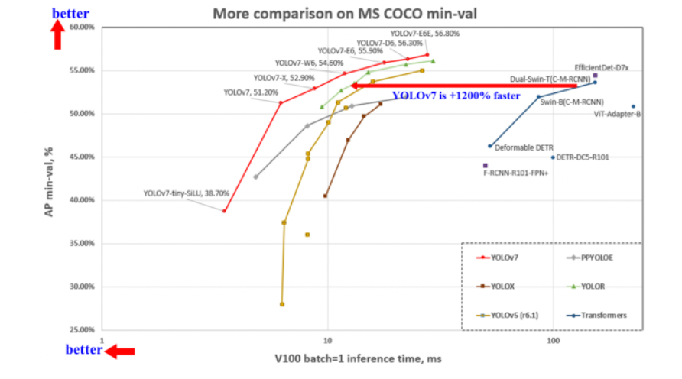

Figure 5: YOLOv7 evaluate diagram

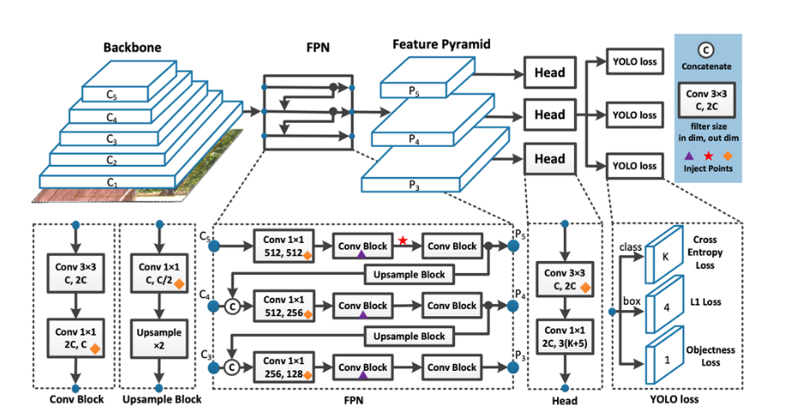

Figure 6: YOLO network Architecture diagram

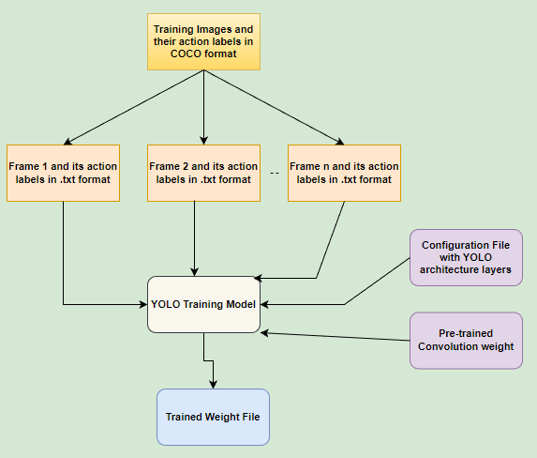

Figure 7: The Flowchart for the training of YOLO

3.6 OpenCV OCR

A library for CVs called OpenCV is used to analyze and manipulate pictures generally. OCR is a specific subset of CV that is focused on extracting text from pictures, while Tesseract is a library for OCR. The OpenCV OCR function, also known as optical character recognition, is intended to read an image file that the user has provided before identifying the text contained within to be shown to the user. This text can be further used for whatever reason the user may have for using the extracted text, but it is particularly important for computer vision applications that operate on a real-time platform and processing. The system must first be installed with tesseract version 4, which has a very accurate deep learning and computer intelligence model that is built particularly for text and character recognition. This model enables the system to conduct optical character recognition from a given image. For my work, I used OpenCV OCR and text recognition with Tesseract for ANPR.ANPR means Automatic number plate recognition. We utilized many libraries for this, imported them, worked on showing the original image, the gray image, the smother image, the canny image, the canny after contours, and the top 30 contours, and then I worked on the final image for each and every image. For the purpose of recognizing license plates, we use anpr code to locate the plate's registration number and record it to a CSV file. We used a camera to make this discovery. The camera automatically appended the license plate number to a CSV file when we displayed the image in webcam mode. In the CSV file have many find like date, license plate, score, and dscore.

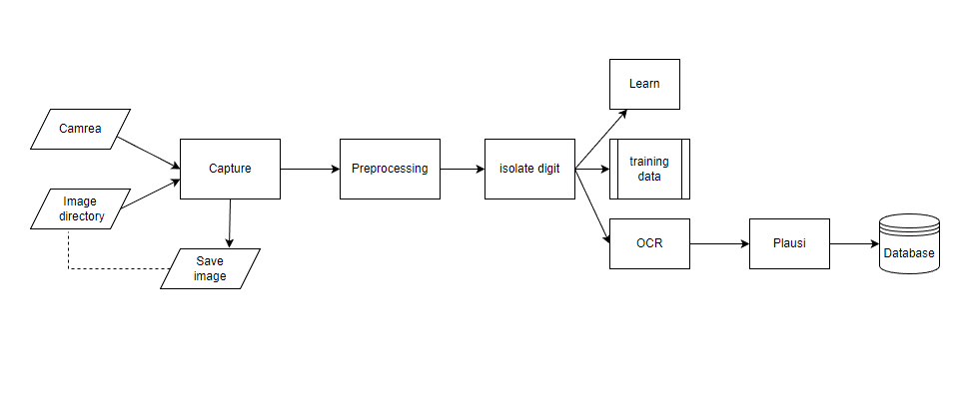

Figure 8: Program flow diagram

3.7 Transfer Learning

Transfer learning is the practice of applying a previously taught model to fresh challenges. It can train deep neural networks with relatively minimal data, which makes it quite popular in deep learning right now. This is extremely helpful in the data science profession because the majority of real-world situations often do not have millions of labeled data points to train such complicated models. Transfer learning is the process of taking a shortcut to reuse previously taught model weights. A neural network is a type of computer system that uses a learned model of one issue to solve another. Transfer learning techniques are capable of identifying common photographic characteristics. Although it reached state-of-the-art performance, the system is still functional.

Although there are many advantages to transfer learning, its key benefits are reduced training time, improved neural network performance (for the most part), and a lack of data needs.

3.8 Evaluation Methods

To assess the outcomes, I have plotted the confusion matrix. False positive and negative values as well as actual positive and negative values are required for evaluation. Since the actual number was as expected, this is a true positive. Correct rejection of true-negative the value is anticipated to be positive but is really a false positive. False-negative is unjustifiably rejected.

**3.8.1 Accuracy**

How well a computer can anticipate results depends on how accurate the model is. When every class is equally significant, something is important. All classes are equally essential to me in my career. As a result, accuracy is crucial in determining the model's correctness. Accuracy may also be determined in terms of positives and negatives for binary classification, as seen below:

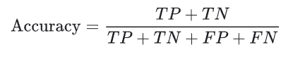

Where TP, TN, FP, and FN stand for "True Positives," "True Negatives," "False Positives," and "True Negatives," respectively.

**3.8.2 Precision**

The number of predictions from the positive class that really fall under it is measured by precision. The genuine positive value is subtracted from the total positive value to compute precision.

Following is a definition of precision:

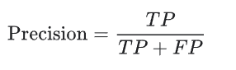

Where TP and FP stand for "True Positives," and "False Positives," respectively.

**3.8.3 Recall**

Recall is a metric for assessing the exact true positive identification. By dividing the genuine positive value by all of the relevant documents that are currently in existence, the recall is determined.

Following is a definition of Recall:

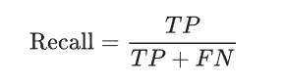

Where TP, and FN stand for "True Positives," and "True Negatives," respectively.

**3.8.4 F1 Score**

Precision and Recall are combined to create the F1 Score. As a result, both false positives and false negatives are considered in this score. F1 is often more beneficial than accuracy, especially if you have an unequal class distribution, despite the fact that it is less intuitively simple to comprehend. False positives and false negatives should cost roughly the same for accuracy to function optimally. It is preferable to take into account both Precision and Recall if the costs of false positives and false negatives are considerably different.

Following is a definition of F1 score:

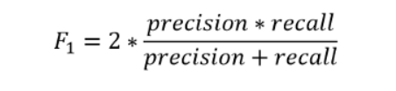

For models named YOLOv7 method, I have shown the mAP along with model accuracy. When calculating model accuracy using mAP, training accuracy and validation accuracy are taken into account.

**3.8.5 Mean Average Precision (mAP)**

The mean average precision (mAP) is used to assess object detection models developed by YOLO. The mAP calculates a score by comparing the detected box to the ground-truth bounding box. The better the score, the more reliable the model's detections are. Over recall levels ranging from 0 to 1, the average accuracy (AP) values (mean) are determined.

The following sub-metrics make up the mAP formula:

* Confusion Matrix,
* Intersection over Union (IoU),
* Recall,
* Precision

**3.8.5.1 Confusion Matrix**

Looking at the confusion matrix is a much better technique to assess a classifier's performance. The main goal is to determine how frequently examples of class a are put in the class B category.

We need the following four properties to make a confusion matrix:

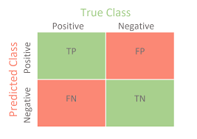

Figure 9: Confusion matrix diagram

* True Positives (TP): matches when the model accurately anticipated the label and the ground truth.
* True Negatives (TN): The label is not predicted by the model, and it is not based on the truth.
* False Positives (FP): When a label is predicted by a model but is not really present in the data (Type I Error).
* False Negatives (FN) are labels that the model does not anticipate, but which are nevertheless true in reality. Error type II.

**3.8.5.2 Intersection over Union (IoU)**

The percentage of overlap between two boxes is measured by the term "Intersection over Union" (IoU). The overlap of the Ground Truth and Prediction area is assessed by IoU in the context of object identification and segmentation.

If you work in computer vision or are just interested in it, you have probably heard the phrase a lot. It serves as the initial test to determine whether a model is accurate. In layman's words, it's a statistic that enables us to assess how accurate a forecast is.

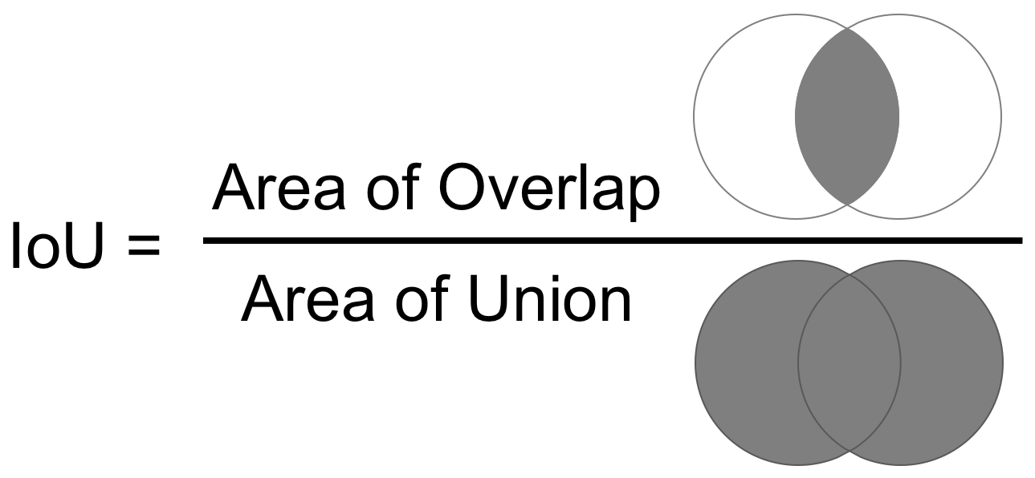

Figure 10: Intersection over Union diagram

CHAPTER 4

RESULTS AND DISCUSSION

4.1 INTRODUCTION

The models and procedures for detecting helmets and recognizing license plates are given. After the data gathering and preparation phase, I detailed the models I used for the detection approach. The outcomes of the model I used will be discussed there.

4.2 RESULT DISCUSSION

After implementing the models we find many results on our dataset. We implemented YOLOv7 for helmet and number plate detection and OpenCV OCR was implemented for number plate recognition. For used YOLOv7 use find weights of the model for our dataset, F1 score, Precision, recall, and mAP value. We also find the model’s loss plotting graph. And then implemented OpenCV OCR we find the number plate digit and many recognition images. To obtain a graph showing the accuracy and loss of every model, training and validation accuracy are compared.

4.2.1 YOLOv7

From the Output of the Yolo v7 result shows that a total of 100 epochs were run on 800 data, of which 4 were classified into classes. In each class, 200 pictures were given out. When we consider the entire output, we see that the accuracy, recall, and map values add up to 65%, 67%, and 62% of all classes, respectively. It's not what you'd expect to get for that amount. We can see that there is a significant variation in the data if we compute based on the various classifications. The number plate class has the most data, with an accuracy value of 85%, a recall value of 90%, and a map value of 90%.

The least amount of data, with a precision value of 49%, is found when a number plate is absent. Coming to 45% while the worth of the map is coming to 37%. Thus, it is clear how much the output has changed as a result of both less and more data. We cannot obtain excellent accuracy if the data is greater or less. Thus, it is crucial to have the same data for all classes.

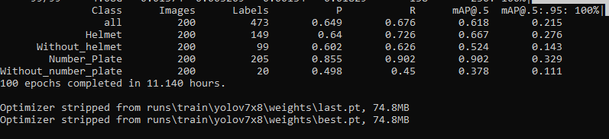

Figure 11: Mapping of YOLOv7

Figure 12 depicts the confusion matrix following the use of the Yolo V7 model. As can be seen, the vertical position has the projected value, whereas the horizontal position has the actual value. If we examine each class individually, we can find that the helmet class has the highest predicted value, which is 0.71. We receive the projected value of 0.68 for the number plate. On the other side, the number plate class wire has the highest value. It has a genuine positive value of 0.87. The lowest expected value, on the other hand, is 0.33 for the number plate without.

If we examine the backdrop FN, we can observe that the license plate has the lowest value. And without the helmet, the value is maximum. Our data are the result since the confusion matrix does not yield satisfactory outcomes.

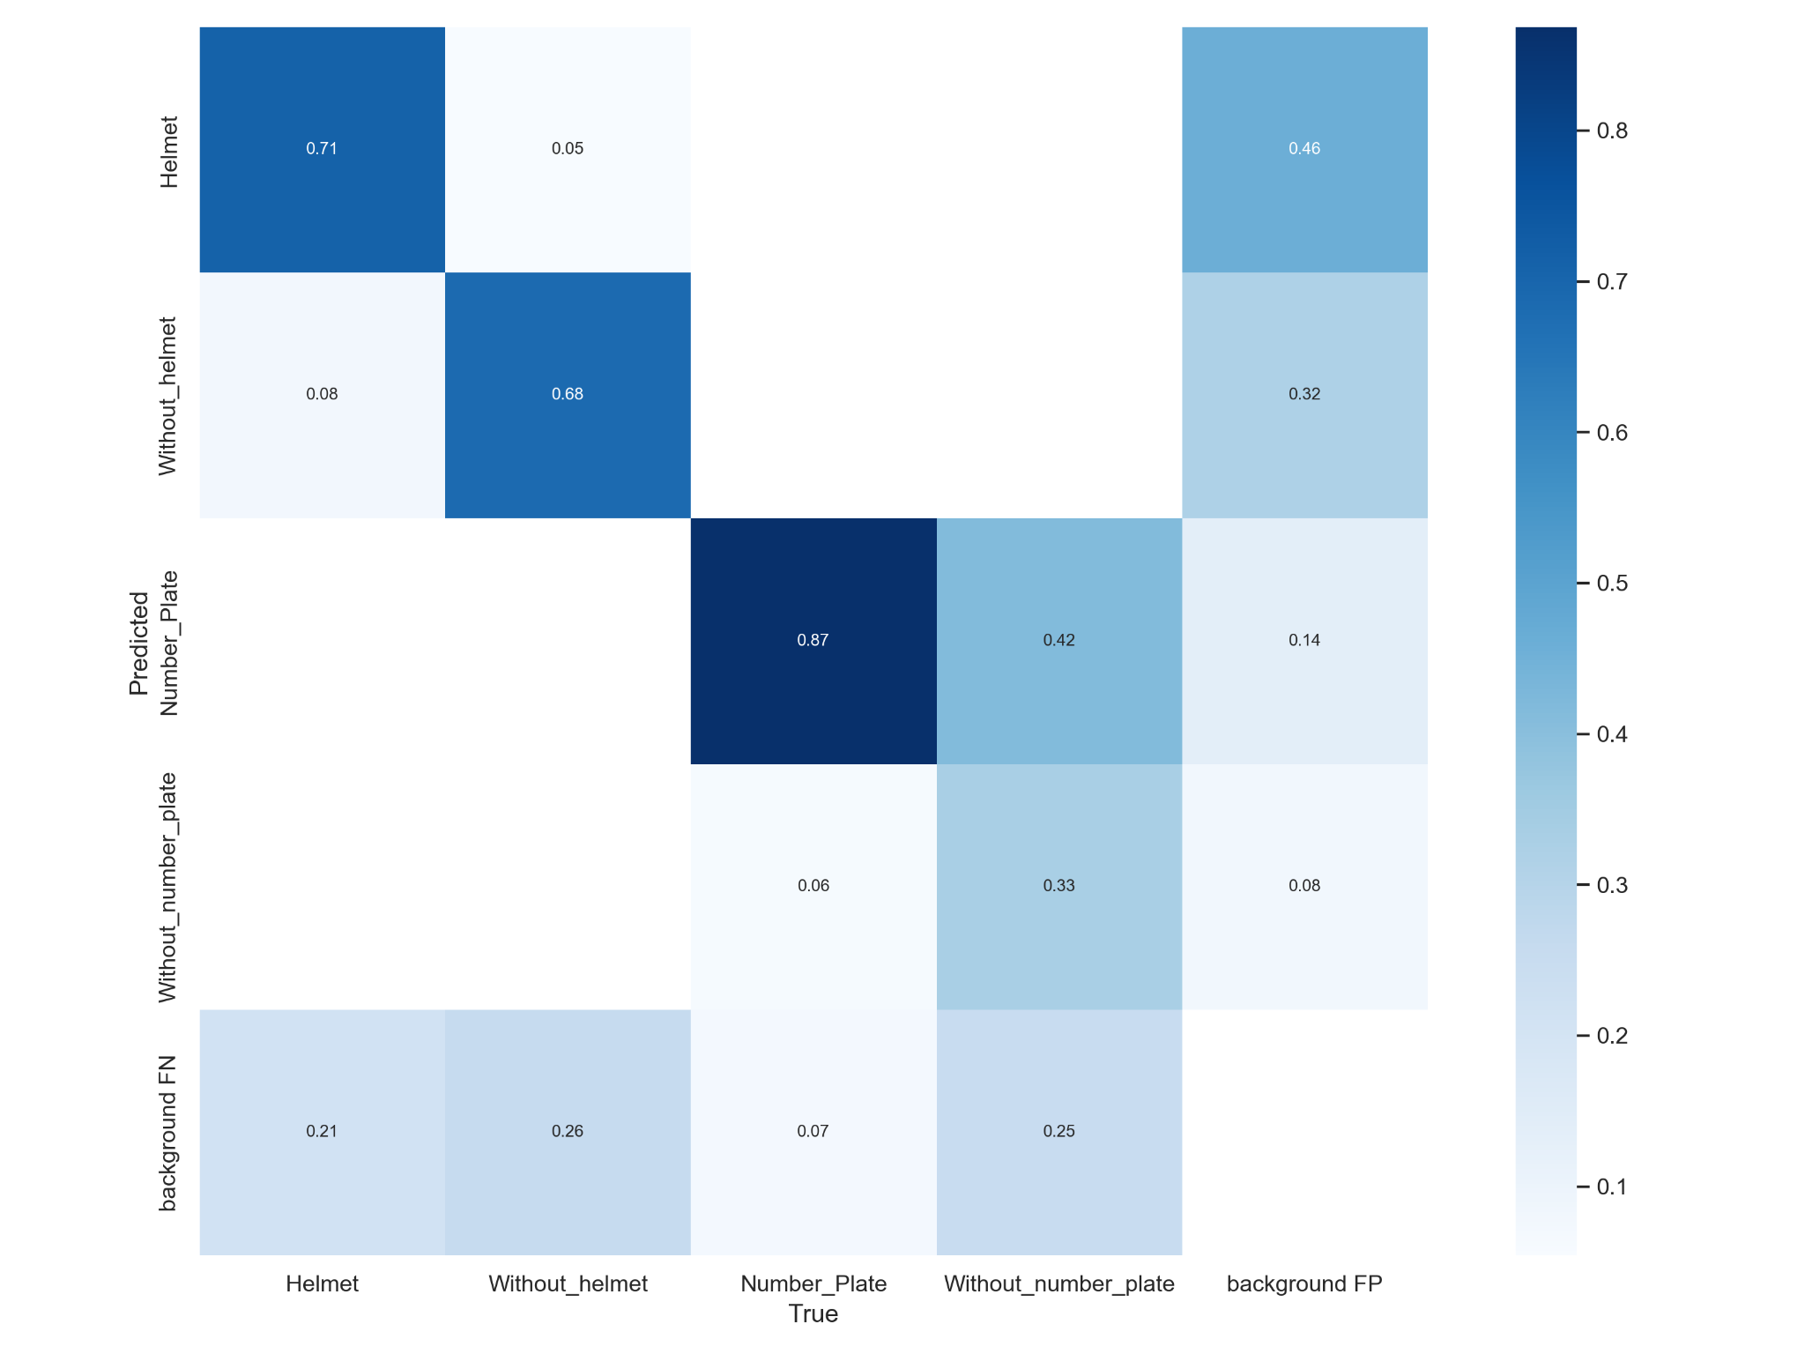

Figure 12: Confusion matrix of YOLOv7

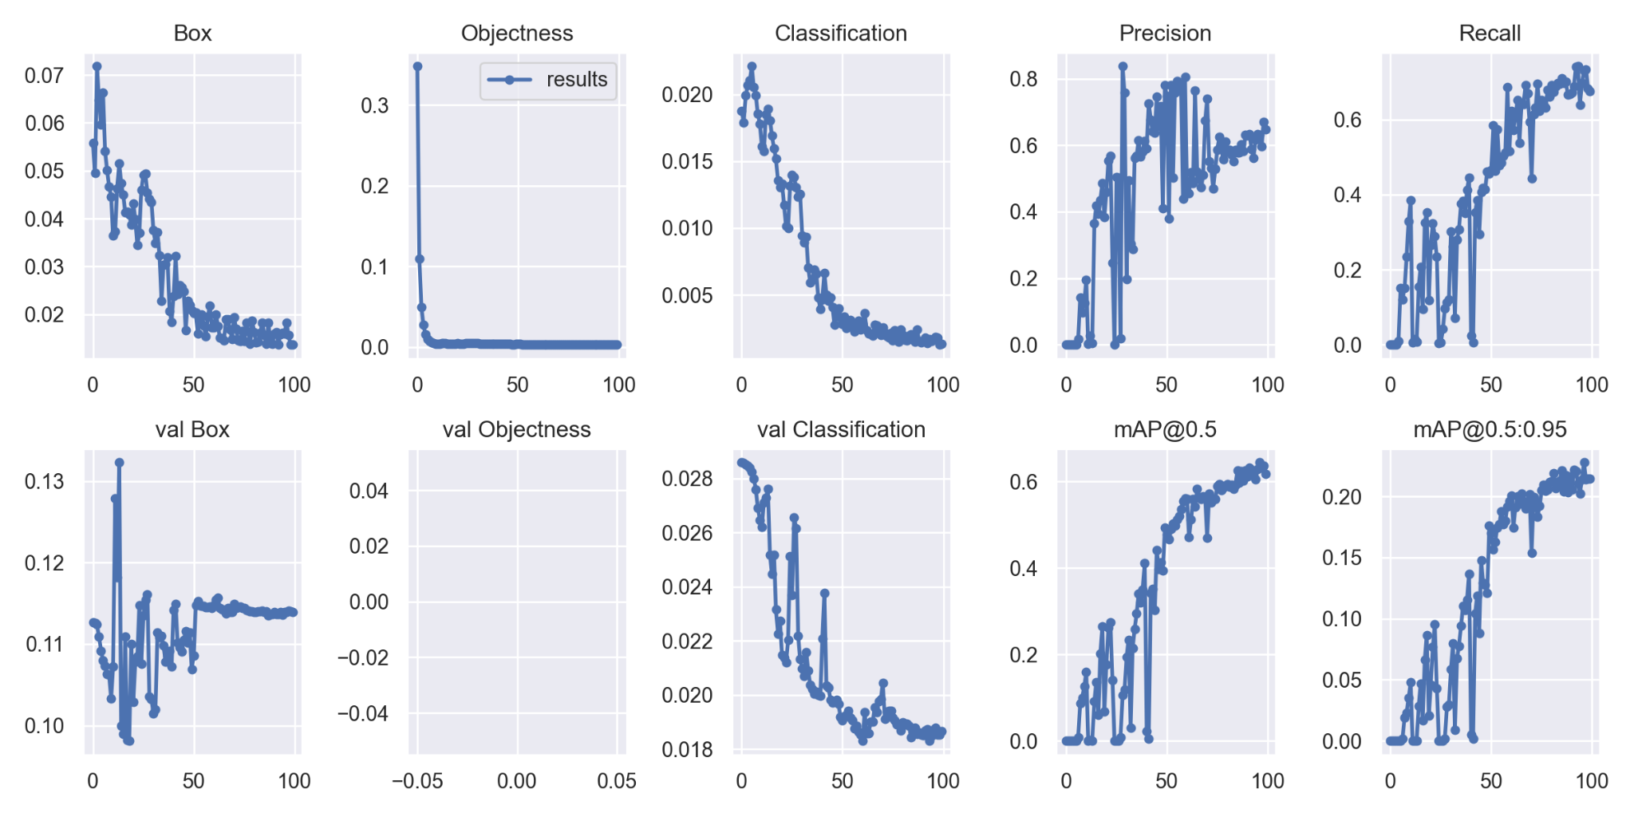

Figure 13: Result of YOLOv7

There are several picture diagrams in Figure 14. Which are essentially all of these: f1 score, precision, and recall. If we examine the graphs, we can see how the class 4 diagrams appear. There are four categories: number plate, sans number plate, and helmet.

We can see that f1 represents the confidence interval in the plot for f1 scores. As f1 rises, confidence will therefore decline. We can observe from this graph that although the other classes are performing well, the class for license plates is not. This class did admirably in the first period but fell short in the final one. If we consider every class, we can find that F1 is 66% accurate.

We can observe that confidence is inversely correlated with precision in the precision diagram. It implies that as confidence rises, accuracy will fall. This graphic demonstrates how the helmet class has significantly decreased by the 85th period. Every class has had ups and downs. If we include all the classes, we can see that the precise accuracy is 100% at 0.904.

We can observe that precision and recall are inversely correlated in the precision-recall diagram. This implies that as accuracy rises, the recall will fall. With an accuracy of 0.90 percent, the number plate class is clearly outperforming the other classes in this graphic. The number plate class, with an accuracy of 0.37%, has the poorest performance. We can observe that the Precision-Recall accuracy is 0.61% if we include all the classes.

We can observe that recall is exponential in the figure. In other words, if recall rises, confidence will fall. The class without a license plate is performing worse than other classes, as seen in the diagram. The number plate class is doing well, and it had the lowest value. The recall accuracy is 0.90 percent at 0.000 if we include all the courses.

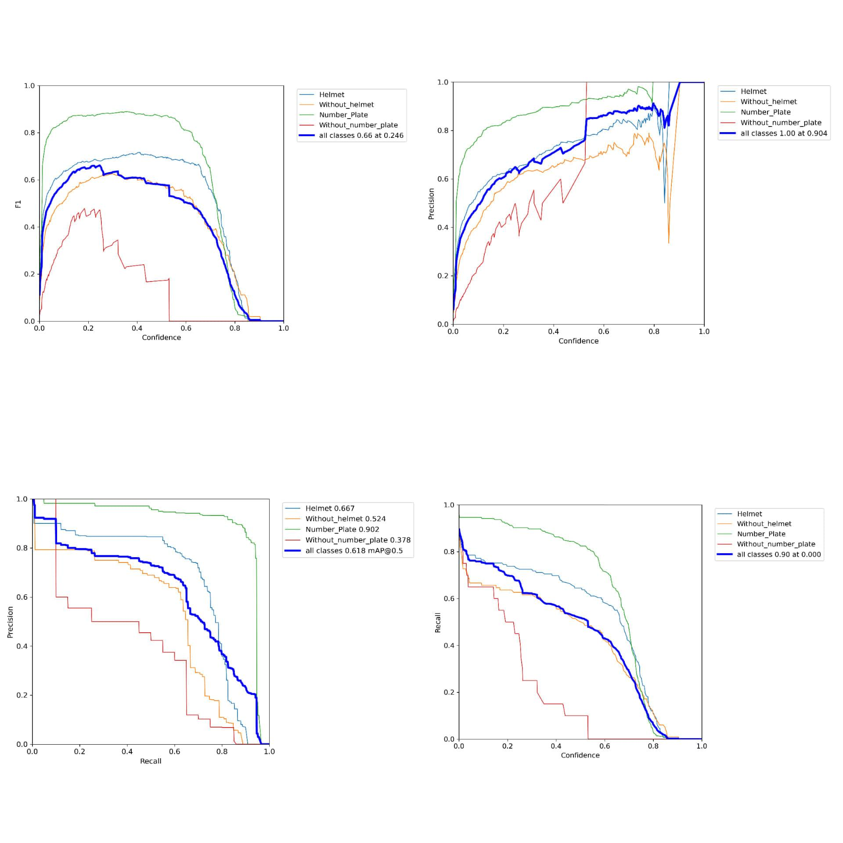

Figure 14: F1, Recall, Precision of YOLOv7

After training our data we see that kind of output. This output shows the detected images. This model easily detects the bikers who wearing a helmet and who not wearing a helmet. And also detect number plates and nonnumber plates.

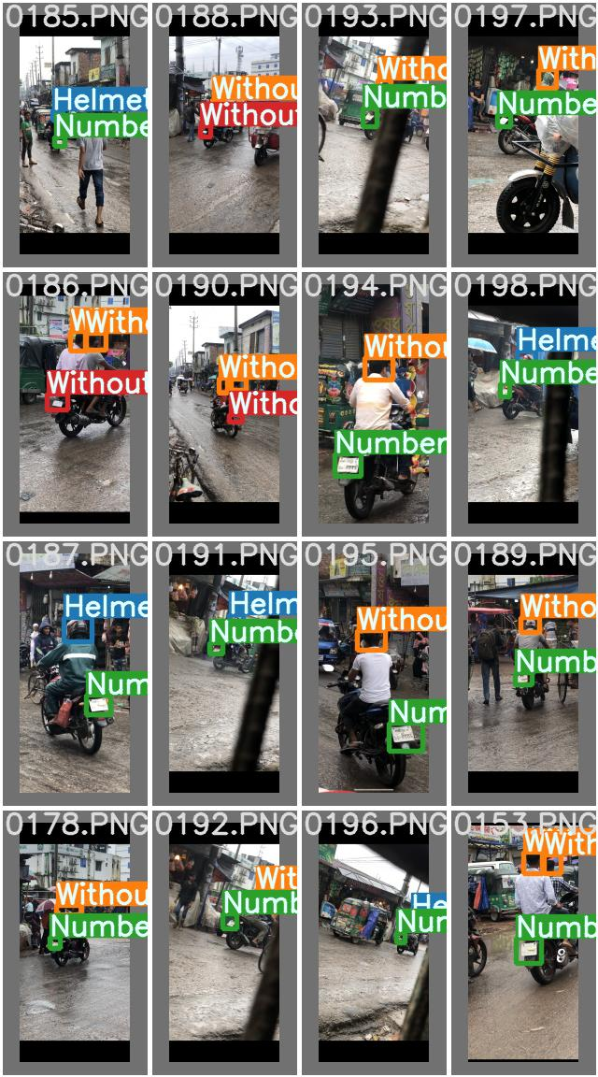

Figure 15: Output of YOLOv7

4.2.2 OpenCV OCR

Figure 16 and figure 17 show the output of OpenCV OCR. We implement this for number plate recognition. When a rider without a helmet is recognized, OpenCV Tesseract OCR is used to find the motorcycle's license plate. After the run code, we find many types of images for the recognition number plates. Firstly we show the original images then gray, smoother, canny, canny after contours, top 30 contours, and at the end show the final image. We are only shown to example output of OpenCV OCR using our own dataset.

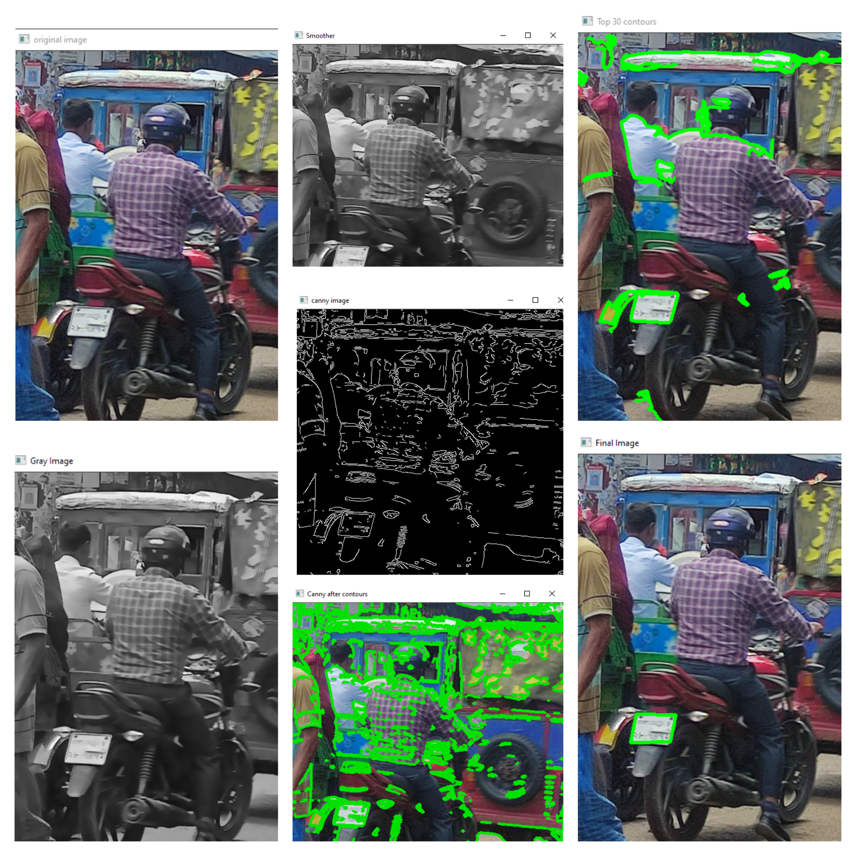

Figure 16: Output of OpenCV OCR (1)

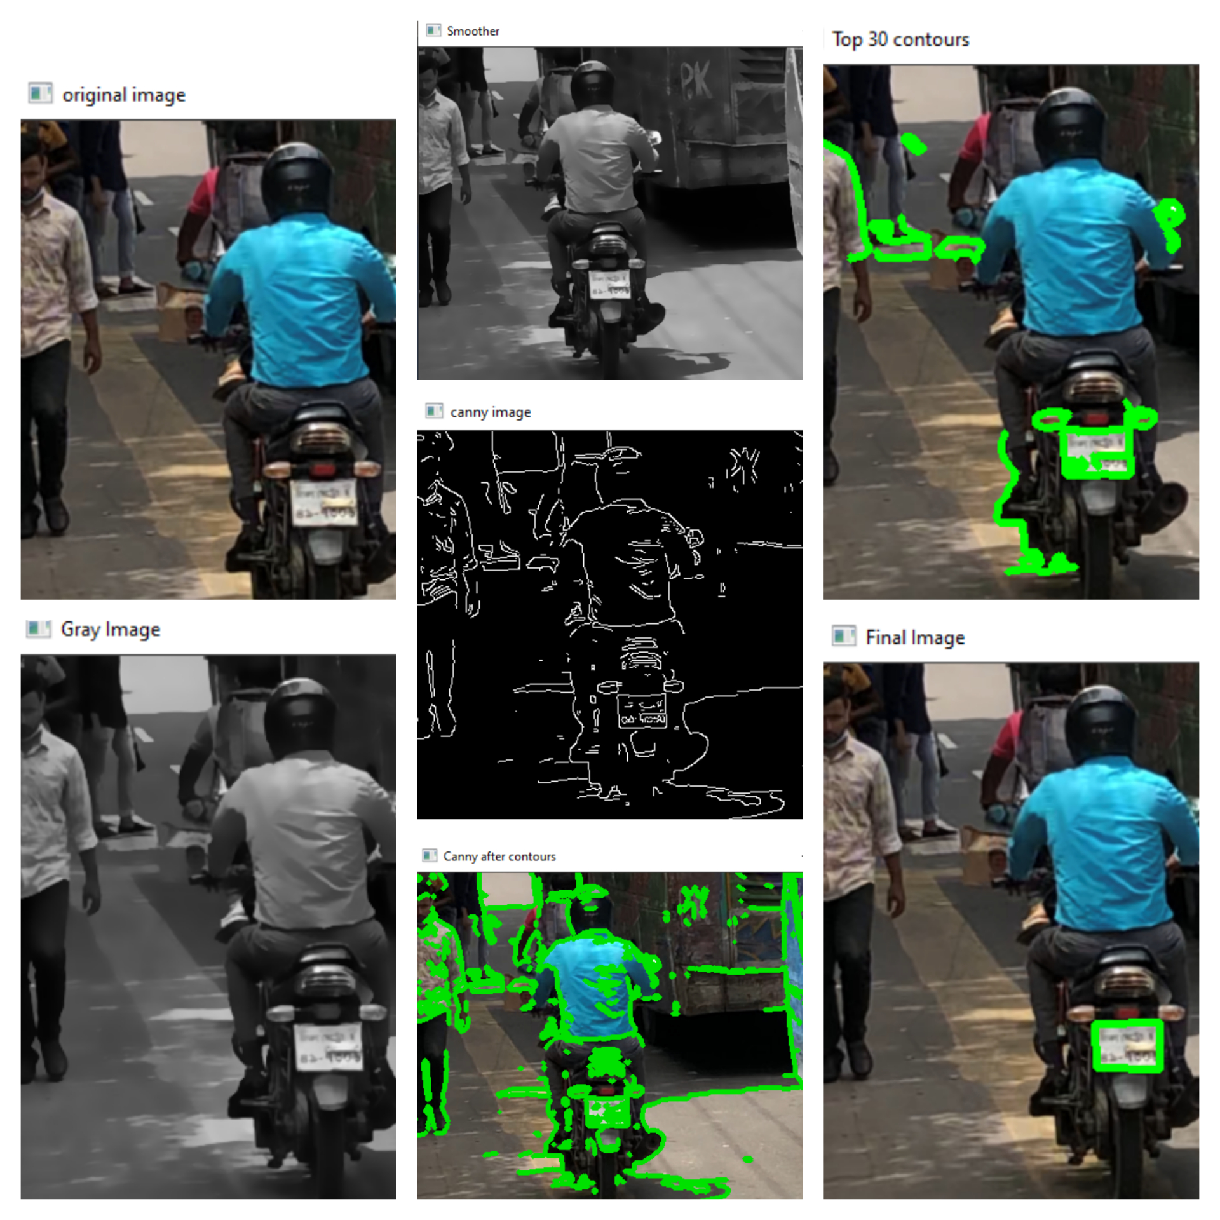

Figure 17: Output of OpenCV OCR (2)

Figs. 18, 19, For ANPR, I combined OpenCV OCR and Tesseract text recognition. For this, various libraries were imported and used. We retrieve the plate's registration number using the anpr code and record it to a CSV file in order to identify license plates. This finding was made with the use of a camera. When we presented the image in webcam mode, the camera immediately attached the license plate number to a CSV file.

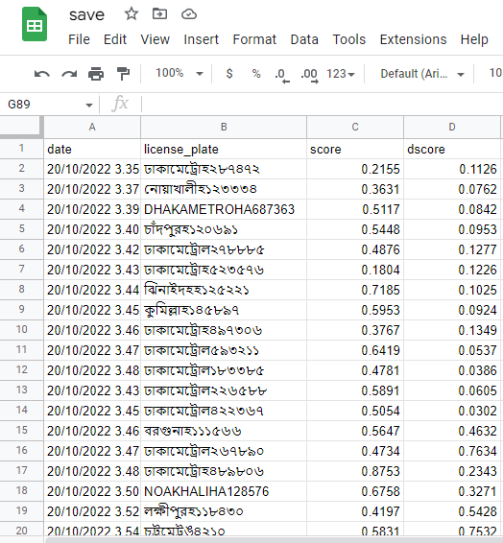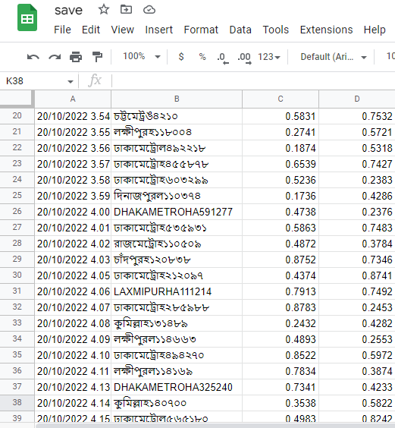

Figure 18: Output of OpenCV number plate Recognition (1)

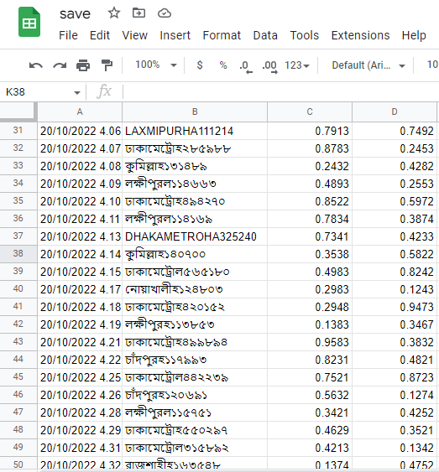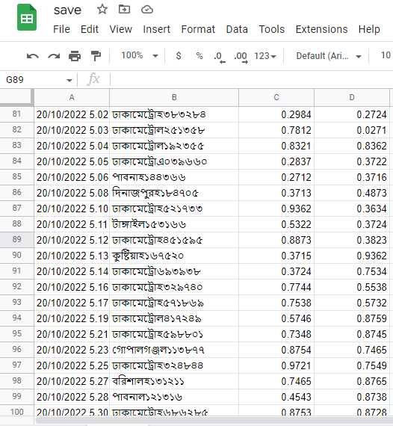

Figure 19: Output of OpenCV number plate Recognition (2)

CHAPTER 5

CONCLUSION AND LIMITATIONS

5.1 CONCLUSION

According to the data shown above, it is clear that YOLO object detection is ideally suited for real-time processing and was successful in properly classifying and localizing all object classes. The suggested end-to-end model was successfully constructed and includes all the necessary components to be automated and deployed for monitoring. In order to extract the license plates, several approaches are used while taking into account various scenarios, such as many helmetless motorcyclists, and are created to handle the majority of situations. Because they are all open source, the libraries and software utilized in our project are incredibly versatile and economical. The initiative was primarily created to address the issue of ineffective traffic management. As a result, we can conclude that if implemented by any traffic management agency, it would facilitate and improve the effectiveness of their work.

5.2 LIMITATIONS

In the work, the output is not much satisfactory. It may be because of the angle of the image data which is on basis of Dhaka city, and many rural areas. Another reason is an augmentation of all images. If we used augmentation images then maybe paper accuracy will increase Further, I will try to take images at perfect angles to get higher mAP. And along with this work, I will try to get the flow of each biker separately and use other models to compare the mAP. I will also try to implement it as an automatic case final system for easily finding the violated bikers who don't use helmets and automatic cases in that bikers.

6. REFERENCES

1. Sanjana, S., Shriya, V. R., Vaishnavi, G., & Ashwini, K. (2021). A review on various methodologies used for vehicle classification, helmet detection and number plate recognition. *Evolutionary Intelligence*, *14*(2), 979-987.
2. Jia, W., Xu, S., Liang, Z., Zhao, Y., Min, H., Li, S., & Yu, Y. (2021). Real‐time automatic helmet detection of motorcyclists in urban traffic using improved YOLOv5 detector. *IET Image Processing*, *15*(14), 3623-3637.
3. SOUNDARYA, B., GADI, S. P., PRAVALIKA, A., & SUMANTH, M. HELMET DETECTION USING MACHINE LEARNING AND AUTOMATIC LICENSE PLATE RECOGNITION.
4. Srilakshmi, M., Chandrika, K., & Sivakumar, K. Helmet Detection. *Journal homepage: www. ijrpr. com ISSN*, *2582*, 7421.
5. Khan, F. A., Nagori, N., & Naik, A. (2020, July). Helmet and number plate detection of motorcyclists using deep learning and advanced machine vision techniques. In *2020 Second International Conference on Inventive Research in Computing Applications (ICIRCA)* (pp. 714-717). IEEE.
6. Choudhury, T., Aggarwal, A., & Tomar, R. (2020). A deep learning approach to helmet detection for road safety.
7. Boonsirisumpun, N., Puarungroj, W., & Wairotchanaphuttha, P. (2018, November). Automatic detector for bikers with no helmet using deep learning. In *2018 22nd International Computer Science and Engineering Conference (ICSEC)* (pp. 1-4). IEEE.
8. Rohith, C. A., Nair, S. A., Nair, P. S., Alphonsa, S., & John, N. P. (2019, April). An efficient helmet detection for MVD using deep learning. In *2019 3rd International Conference on Trends in Electronics and Informatics (ICOEI)* (pp. 282-286). IEEE.
9. Talaulikar, A. S., Sanathanan, S., & Modi, C. N. (2019). An enhanced approach for detecting helmet on motorcyclists using image processing and machine learning techniques. In *Advanced Computing and Communication Technologies* (pp. 109-119). Springer, Singapore.
10. Manocha, D., Purkayastha, A., Chachra, Y., Rastogi, N., & Goel, V. (2019, March). Helmet Detection Using ML & IoT. In *2019 International Conference on Signal Processing and Communication (ICSC)* (pp. 355-358). IEEE.
11. Allamki, L., Panchakshari, M., Sateesha, A., & Pratheek, K. S. (2019). Helmet detection using machine learning and automatic License Plate Recognition. *International Research Journal of Engineering and Technology (IRJET)*, *6*(12).
12. Devadiga, K., Gujarathi, Y., Khanapurkar, P., Joshi, S., Deshpande, S., Devadiga, K., ... & Deshpande, S. (2018). Real time automatic helmet detection of bike riders. *International Journal*, *4*, 146-148.
13. Raj, K. D., Chairat, A., Timtong, V., Dailey, M. N., & Ekpanyapong, M. (2018, January). Helmet violation processing using deep learning. In *2018 International Workshop on Advanced Image Technology (IWAIT)* (pp. 1-4). IEEE.
14. Hayat, A., & Morgado-Dias, F. (2022). Deep Learning-Based Automatic Safety Helmet Detection System for Construction Safety. *Applied Sciences*, *12*(16), 8268.
15. Deng, L., Li, H., Liu, H., & Gu, J. (2022). A lightweight YOLOv3 algorithm used for safety helmet detection. *Scientific reports*, *12*(1), 1-15.
16. Otgonbold, M. E., Gochoo, M., Alnajjar, F., Ali, L., Tan, T. H., Hsieh, J. W., & Chen, P. Y. (2022). SHEL5K: an extended dataset and benchmarking for safety helmet detection. *Sensors*, *22*(6), 2315.
17. Zhang, B., Sun, C. F., Fang, S. Q., Zhao, Y. H., & Su, S. (2022). Workshop safety helmet wearing detection model based on SCM-YOLO. *Sensors*, *22*(17), 6702.
18. Wu, F., Jin, G., Gao, M., Zhiwei, H. E., & Yang, Y. (2019, May). Helmet detection based on improved YOLO V3 deep model. In *2019 IEEE 16th International Conference on Networking, Sensing and Control (ICNSC)* (pp. 363-368). IEEE.
19. Li, K., Zhao, X., Bian, J., & Tan, M. (2018). Automatic safety helmet wearing detection. *arXiv preprint arXiv:1802.00264*.
20. Tan, S., Lu, G., Jiang, Z., & Huang, L. (2021, March). Improved YOLOv5 network model and application in safety helmet detection. In *2021 IEEE International Conference on Intelligence and Safety for Robotics (ISR)* (pp. 330-333). IEEE.
21. Dasgupta, M., Bandyopadhyay, O., & Chatterji, S. (2019, December). Automated helmet detection for multiple motorcycle riders using CNN. In *2019 IEEE Conference on Information and Communication Technology* (pp. 1-4). IEEE.
22. Cheng, R., He, X., Zheng, Z., & Wang, Z. (2021). Multi-scale safety helmet detection based on SAS-YOLOv3-tiny. *Applied Sciences*, *11*(8), 3652.
23. Jia, W., Xu, S., Liang, Z., Zhao, Y., Min, H., Li, S., & Yu, Y. (2021). Real‐time automatic helmet detection of motorcyclists in urban traffic using improved YOLOv5 detector. *IET Image Processing*, *15*(14), 3623-3637.
24. Jin, Z., Qu, P., Sun, C., Luo, M., Gui, Y., Zhang, J., & Liu, H. (2021). DWCA-YOLOv5: An improve single shot detector for safety helmet detection. *Journal of Sensors*, *2021*.
25. Kashyap, A., Suresh, B., Patil, A., Sharma, S., & Jaiswal, A. (2018, October). Automatic number plate recognition. In *2018 international conference on advances in computing, communication control and networking (ICACCCN)* (pp. 838-843). IEEE.
26. Babu, R. N., Sowmya, V., & Soman, K. P. (2019, July). Indian car number plate recognition using deep learning. In *2019 2nd international conference on intelligent computing, instrumentation and control technologies (ICICICT)* (Vol. 1, pp. 1269-1272). IEEE.
27. Kakani, B. V., Gandhi, D., & Jani, S. (2017, July). Improved OCR based automatic vehicle number plate recognition using features trained neural network. In *2017 8th international conference on computing, communication and networking technologies (ICCCNT)* (pp. 1-6). IEEE.
28. Benyang, D., Xiaochun, L., & Miao, Y. (2020, November). Safety helmet detection method based on YOLO v4. In *2020 16th International Conference on Computational Intelligence and Security (CIS)* (pp. 155-158). IEEE.
29. Wang, H., Hu, Z., Guo, Y., Yang, Z., Zhou, F., & Xu, P. (2020). A real-time safety helmet wearing detection approach based on CSYOLOv3. *Applied Sciences*, *10*(19), 6732.
30. Prajwal, M. J., Tejas, K. B., Varshad, V., Murgod, M. M., & Shashidhar, R. (2019). Detection of non-helmet riders and extraction of license plate number using Yolo v2 and OCR method. *International Journal of Innovative Technology and Exploring Engineering (IJITEE)*, *9*(2), 5167-5172.

7. PLAGARISM REPORT

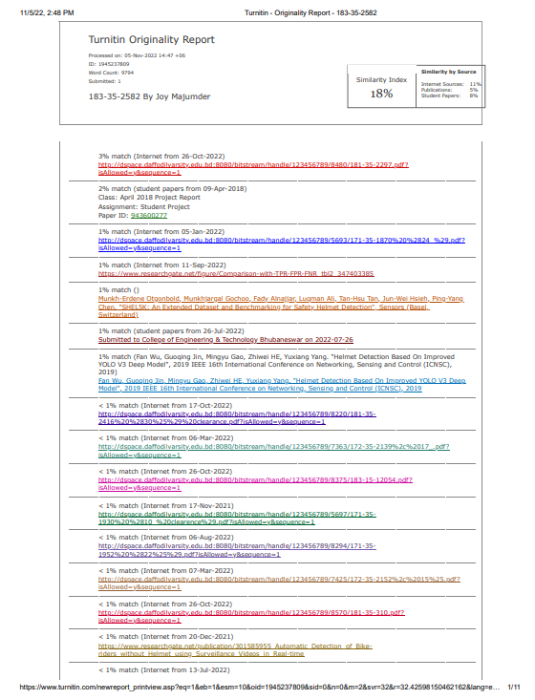

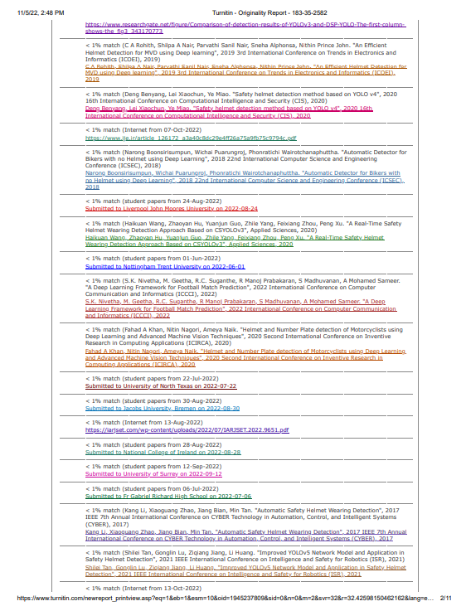

8. ACCOUNT CLEARENCE

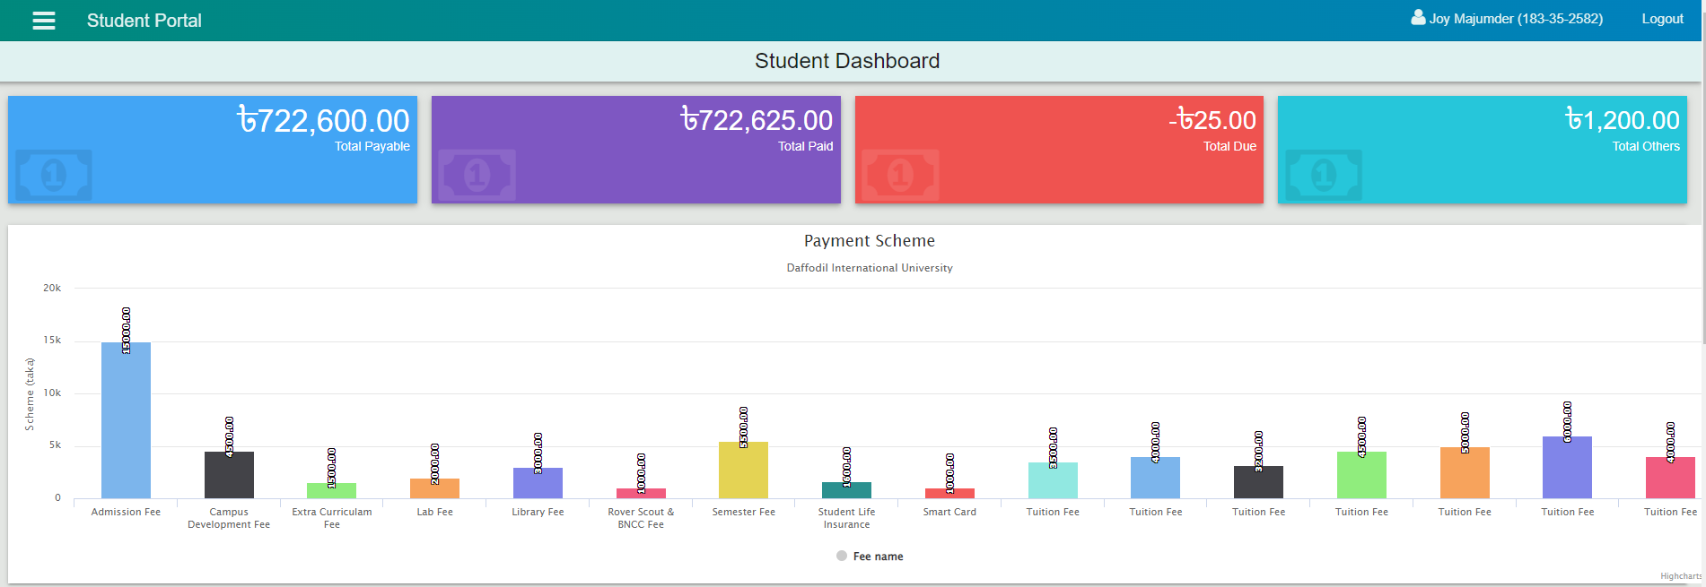

9. LIBRARY CLEARENCE

